Cointegration and ECM: USDJPY and USDCAD
Method 27 / Engle-Granger on log closes / one-lag ECM / Alpari D1 full available history

Study setup
Logical pair: PX=USDJPY , PY=USDCAD
Broker symbols: USDJPY_i , USDCAD_i
Snapshot: 2026-11-03_majors_alpari_D1
Timeframe: D1
Matched window: 1999-01-05 to 2026-11-02 (UTC bar dates)
Matched level count n: 7186
Dropped unfinished last bar dated 2026-11-03 UTC after a tick-volume check against the prior complete day.
ECM lags of deltas: 1
Complete matched rows (Excel): USDJPY-USDCAD_Coint_D1.xlsx
Complete matched rows (HTML table): USDJPY-USDCAD_Coint_D1_data.html

Method carried forward
Engle-Granger cointegration works on log price levels, not returns. For each unordered pair, PX is the left leg and PY the right leg. Step one: OLS ln(PY) = alpha + beta * ln(PX) + e. Step two: statsmodels Engle-Granger coint test on (ln(PY), ln(PX)). Error-correction: delta ln(PY)_t = c + kappa * e_{t-1} + lagged delta ln(PY) and delta ln(PX) (one lag each) + u_t. Headline is the Engle-Granger p-value (lower = stronger evidence of a stationary spread) with kappa and beta reported alongside. Same-sample Pearson r of log returns is a side check only. beta is not an automatic lot-size hedge. This is not a trading signal.

Results (headline)
alpha: -2.260759
beta: 0.527080
Engle-Granger t: -2.310344
Engle-Granger p: 0.368403
5% critical value: -3.336981
ECM kappa: -0.001522
kappa t-stat: -2.6081
ECM R^2: 0.002706
spread std: 0.103862
Pearson r (returns): 0.027603

Conclusion
Engle-Granger for PY=USDCAD on PX=USDJPY: beta=0.5271, alpha=-2.2608, coint_t=-2.3103, p=0.3684 (5% crit=-3.3370). ECM kappa=-0.0015 (t=-2.61). Pearson r of returns = 0.0276. beta is not a lot-size hedge. Not a trading signal.

Charts
Daily closes

Engle-Granger residual spread
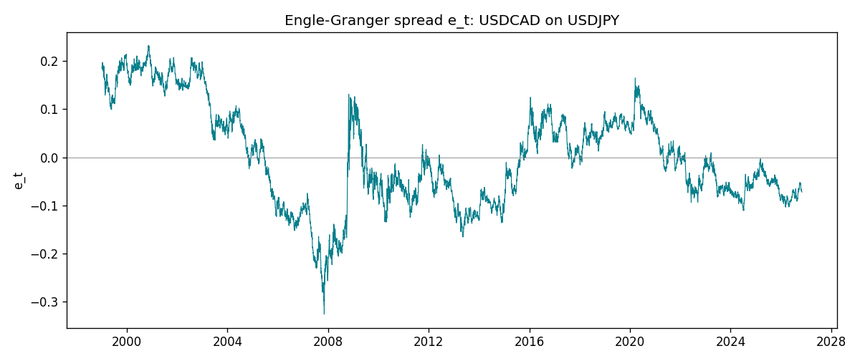
Daily log returns
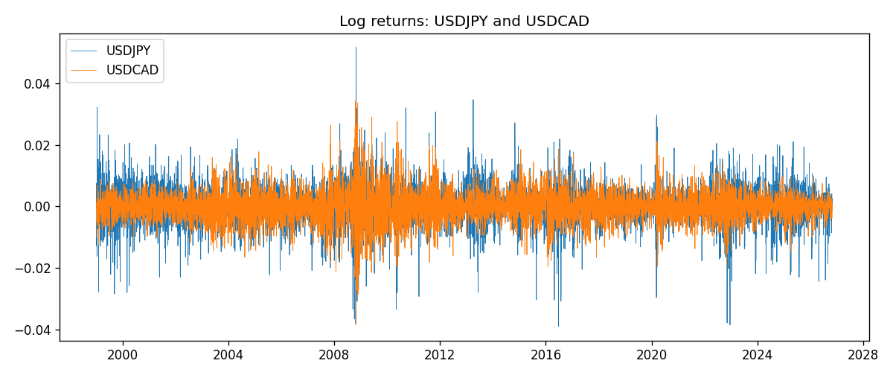

Data report
Matched rows are in the sibling Excel workbook named USDJPY-USDCAD_Coint_D1.xlsx. Embedding all rows as a Word table is impractical; this file holds column summaries and the first and last 15 matched rows.
Column summaries
column | count | mean | std | min | 25% | 50% | 75% | max
USDJPY_open | 7186 | 113.80748 | 19.222412 | 75.693 | 104.39025 | 110.981 | 120.70625 | 163.824
USDCAD_open | 7186 | 1.266789 | 0.16892251 | 0.9168 | 1.118445 | 1.2985 | 1.37213 | 1.6183
USDJPY_high | 7186 | 114.30511 | 19.284087 | 76.001 | 104.8685 | 111.4395 | 121.2675 | 163.978
USDCAD_high | 7186 | 1.2716872 | 0.16888037 | 0.9336 | 1.122975 | 1.303895 | 1.37655 | 1.619
USDJPY_low | 7186 | 113.28446 | 19.150257 | 75.402 | 103.88 | 110.53 | 120.1715 | 163.628
USDCAD_low | 7186 | 1.2622311 | 0.16895752 | 0.9056 | 1.114125 | 1.293555 | 1.367815 | 1.6102
USDJPY_close | 7186 | 113.82065 | 19.237762 | 75.811 | 104.38275 | 111.018 | 120.69375 | 163.851
USDCAD_close | 7186 | 1.2668036 | 0.16889539 | 0.916 | 1.118165 | 1.29848 | 1.372395 | 1.6137
USDJPY_tick_volume | 7186 | 106329.64 | 179429.89 | 149 | 9948.5 | 53187 | 92874.5 | 1803508
USDCAD_tick_volume | 7186 | 81037.769 | 147318.12 | 37 | 5546.5 | 40944 | 71631 | 1410818
USDJPY_spread | 7186 | 20.270804 | 17.617829 | 0 | 6 | 11 | 30 | 50
USDCAD_spread | 7186 | 23.436682 | 18.263202 | 0 | 9 | 17 | 40 | 60
USDJPY_real_volume | 7186 | 3.4776211e+10 | 1.6092546e+11 | 0 | 0 | 0 | 0 | 3.8834203e+12
USDCAD_real_volume | 7186 | 1.8381818e+10 | 9.6701063e+10 | 0 | 0 | 0 | 0 | 2.5751613e+12
USDJPY_log_price | 7186 | 4.7205345 | 0.16792073 | 4.3282434 | 4.6480644 | 4.7096924 | 4.7932564 | 5.0989575
USDCAD_log_price | 7186 | 0.22734107 | 0.13645824 | -0.08773891 | 0.11168894 | 0.26119435 | 0.31655739 | 0.47852968
USDJPY_log_return | 7186 | 5.053e-05 | 0.00620694 | -0.03908203 | -0.00319936 | 0.00011986 | 0.0034094 | 0.05184024
USDCAD_log_return | 7186 | -1.555e-05 | 0.00514357 | -0.03859748 | -0.00283709 | 4.741e-05 | 0.00272359 | 0.03436319
spread_e | 7186 | -0 | 0.10386164 | -0.32624095 | -0.07606802 | -0.01375833 | 0.07341951 | 0.23238191
ecm_fitted | 7185 | -1.414e-05 | 0.00026752 | -0.00115427 | -0.00018917 | -1.479e-05 | 0.00015826 | 0.0013836
First 15 matched rows (selected columns)
time | USDJPY_log_price | USDCAD_log_price | spread_e | USDJPY_log_return | USDCAD_log_return
1999-01-05 | 4.7177843 | 0.41363167 | 0.18774014 | -0.00017868311 | -0.010131666
1999-01-06 | 4.7253503 | 0.41330099 | 0.18342157 | 0.0075660159 | -0.0003306769
1999-01-07 | 4.7124988 | 0.4148212 | 0.19171559 | -0.012851583 | 0.0015202092
1999-01-08 | 4.7077268 | 0.41277168 | 0.19218129 | -0.0047719894 | -0.0020495197
1999-01-11 | 4.6915314 | 0.40925791 | 0.1972038 | -0.016195423 | -0.0035137769
1999-01-12 | 4.7238417 | 0.41587738 | 0.18679312 | 0.032310364 | 0.0066194721
1999-01-13 | 4.731979 | 0.4204194 | 0.18704612 | 0.0081373171 | 0.0045420214
1999-01-14 | 4.731979 | 0.42735705 | 0.19398378 | 0 | 0.0069376546
1999-01-15 | 4.7375134 | 0.42166649 | 0.18537617 | 0.0055343401 | -0.0056905671
1999-01-18 | 4.737601 | 0.42264993 | 0.18631344 | 8.7600193e-05 | 0.00098344542
1999-01-19 | 4.731979 | 0.42539845 | 0.19202517 | -0.0056219403 | 0.002748513
1999-01-20 | 4.726591 | 0.41943376 | 0.18890038 | -0.0053879917 | -0.0059646885
1999-01-21 | 4.7350574 | 0.41515138 | 0.18015553 | 0.0084664056 | -0.0042823796
1999-01-22 | 4.7410987 | 0.41765715 | 0.17947707 | 0.0060412564 | 0.0025057712
1999-01-25 | 4.7337393 | 0.41851295 | 0.18421188 | -0.0073594164 | 0.00085579808
Last 15 matched rows (selected columns)
time | USDJPY_log_price | USDCAD_log_price | spread_e | USDJPY_log_return | USDCAD_log_return
2026-10-13 | 5.0645236 | 0.3516423 | -0.057008596 | -0.0018932826 | -0.0046395653
2026-10-14 | 5.0645994 | 0.35316078 | -0.055530074 | 7.5800166e-05 | 0.0015184751
2026-10-15 | 5.0627469 | 0.34955063 | -0.058163844 | -0.0018524319 | -0.0036101503
2026-10-16 | 5.0623672 | 0.34611842 | -0.061395886 | -0.00037976126 | -0.0034322068
2026-10-19 | 5.0658618 | 0.34423489 | -0.065121398 | 0.0034946841 | -0.0018835331
2026-10-20 | 5.0636072 | 0.34052829 | -0.06763961 | -0.0022546642 | -0.0037066008
2026-10-21 | 5.0632783 | 0.33968137 | -0.068313205 | -0.00032883504 | -0.00084691787
2026-10-22 | 5.0546841 | 0.33705064 | -0.066414065 | -0.0085942669 | -0.0026307268
2026-10-23 | 5.0550349 | 0.3370792 | -0.066570412 | 0.00035080446 | 2.85545e-05
2026-10-26 | 5.0591588 | 0.3371363 | -0.068686918 | 0.0041238746 | 5.7106554e-05
2026-10-27 | 5.0619239 | 0.33967425 | -0.067606436 | 0.0027651658 | 0.0025379458
2026-10-28 | 5.0609671 | 0.33583632 | -0.070940056 | -0.00095679538 | -0.0038379274
2026-10-29 | 5.0605867 | 0.33572196 | -0.0708539 | -0.00038043789 | -0.00011436495
2026-10-30 | 5.059527 | 0.33469208 | -0.071325254 | -0.0010596481 | -0.0010298736
2026-11-02 | 5.0621709 | 0.33530727 | -0.072103585 | 0.0026438521 | 0.00061519094

